Constrained Multiple Sequence Alignment Tool Development and Its Application to RNase Family Alignment
Chuan Yi Tang et al.
Abstract

- Introduction.
- Preliminaries
- Constrained Pairwise Sequence Alignment
Lemma 3.1 For all 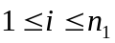 and 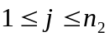, if 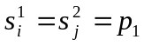, then we have 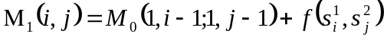; otherwise 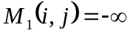.

Lemma 3.2 For all , and 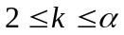, if 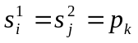, then we have ; otherwise 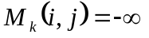.

Lemma 3.3 .

- Constrained Multiple Sequence Alignment
Time-complexity 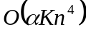
Created by: Ing-Jer Liao
Date: June 6, 2002

